|  |  |
| --- | --- |
| **Website:**  **Trenton, New Jersey: Office of Emergency Management** | **See other content Figure 1** |

|  |  |
| --- | --- |
| Mitigation |  |
| Plan and Prepare | See Figure 2 |
| Response |  |
| Recovery |  |
| My Community:  Stay informed | |  |  | | --- | --- | | Trenton Dashboard | <https://trenton-covid-19-response-trenton-fire.hub.arcgis.com/> |  * + 1. For COVID-19 Mitigation Updates, Numbers etc.   1. One the web (Drop down)  |  |  |  |  |  |  | | --- | --- | --- | --- | --- | --- | | State | |  |  | | --- | --- | | New Jersey: Office of Emergency Management | <http://ready.nj.gov/index.shtml> | | New Jersey: Office of Homeland Security and Preparedness | <http://ready.nj.gov/training/schedule.shtml> | | | Federal | |  |  | | --- | --- | | General: Office of Emergency Management-Training & Exercises Public Dashboard | <https://veoci.com/veoci/p/dashboard/var4jfnvj7> | |  * 1. Social media  |  |  | | --- | --- | | Facebook |  | | Twitter |  |      * 1. Alerts-mobile/text (SMS) & Email Reference Figure 3   2. NOAA Weather Radio   3. Traditional Media |
|  |  |
| Training | |  |  | | --- | --- | | FEMA | <https://training.fema.gov/hiedu/> | | National Fire Academy | <https://www.usfa.fema.gov/training/nfa/> | | The College List  Colleges, Universities and Institutions Offering Emergency Management Courses | <https://training.fema.gov/hiedu/collegelist/> | |

**Information Dissemination:(Everything bilingual (Spanish and English)**

1. Social media
2. 3 by 5 card/hangers

|  |  |
| --- | --- |
| 888777 | Alerts-mobile/text (SMS) & Email |

**Content Dissemination**

COVID-19

Storm ready

Flooding

Smoke alarms

Fire plan/escape routes

Water safety

Preparedness ready

Go kit

|  |  |
| --- | --- |
| **Local Emergency Planning Committee (LEPC)** | FEMA Description <https://www.fema.gov/pdf/emergency/nims/lepc_fs.pdf> |

Figure 1:

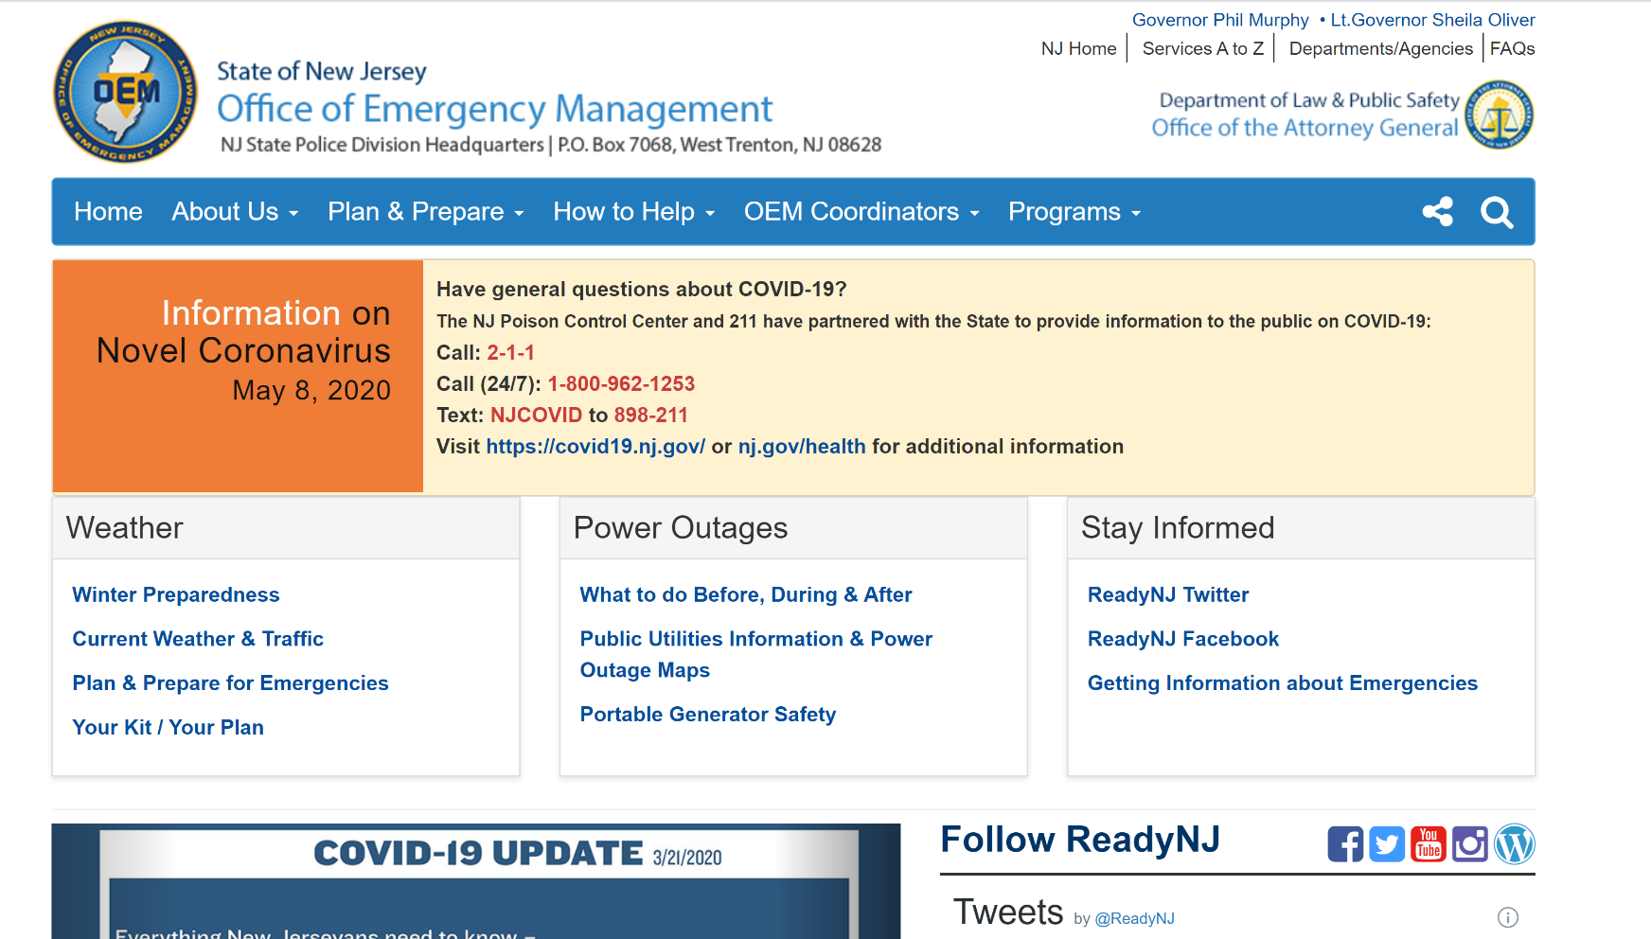

Figure 2:

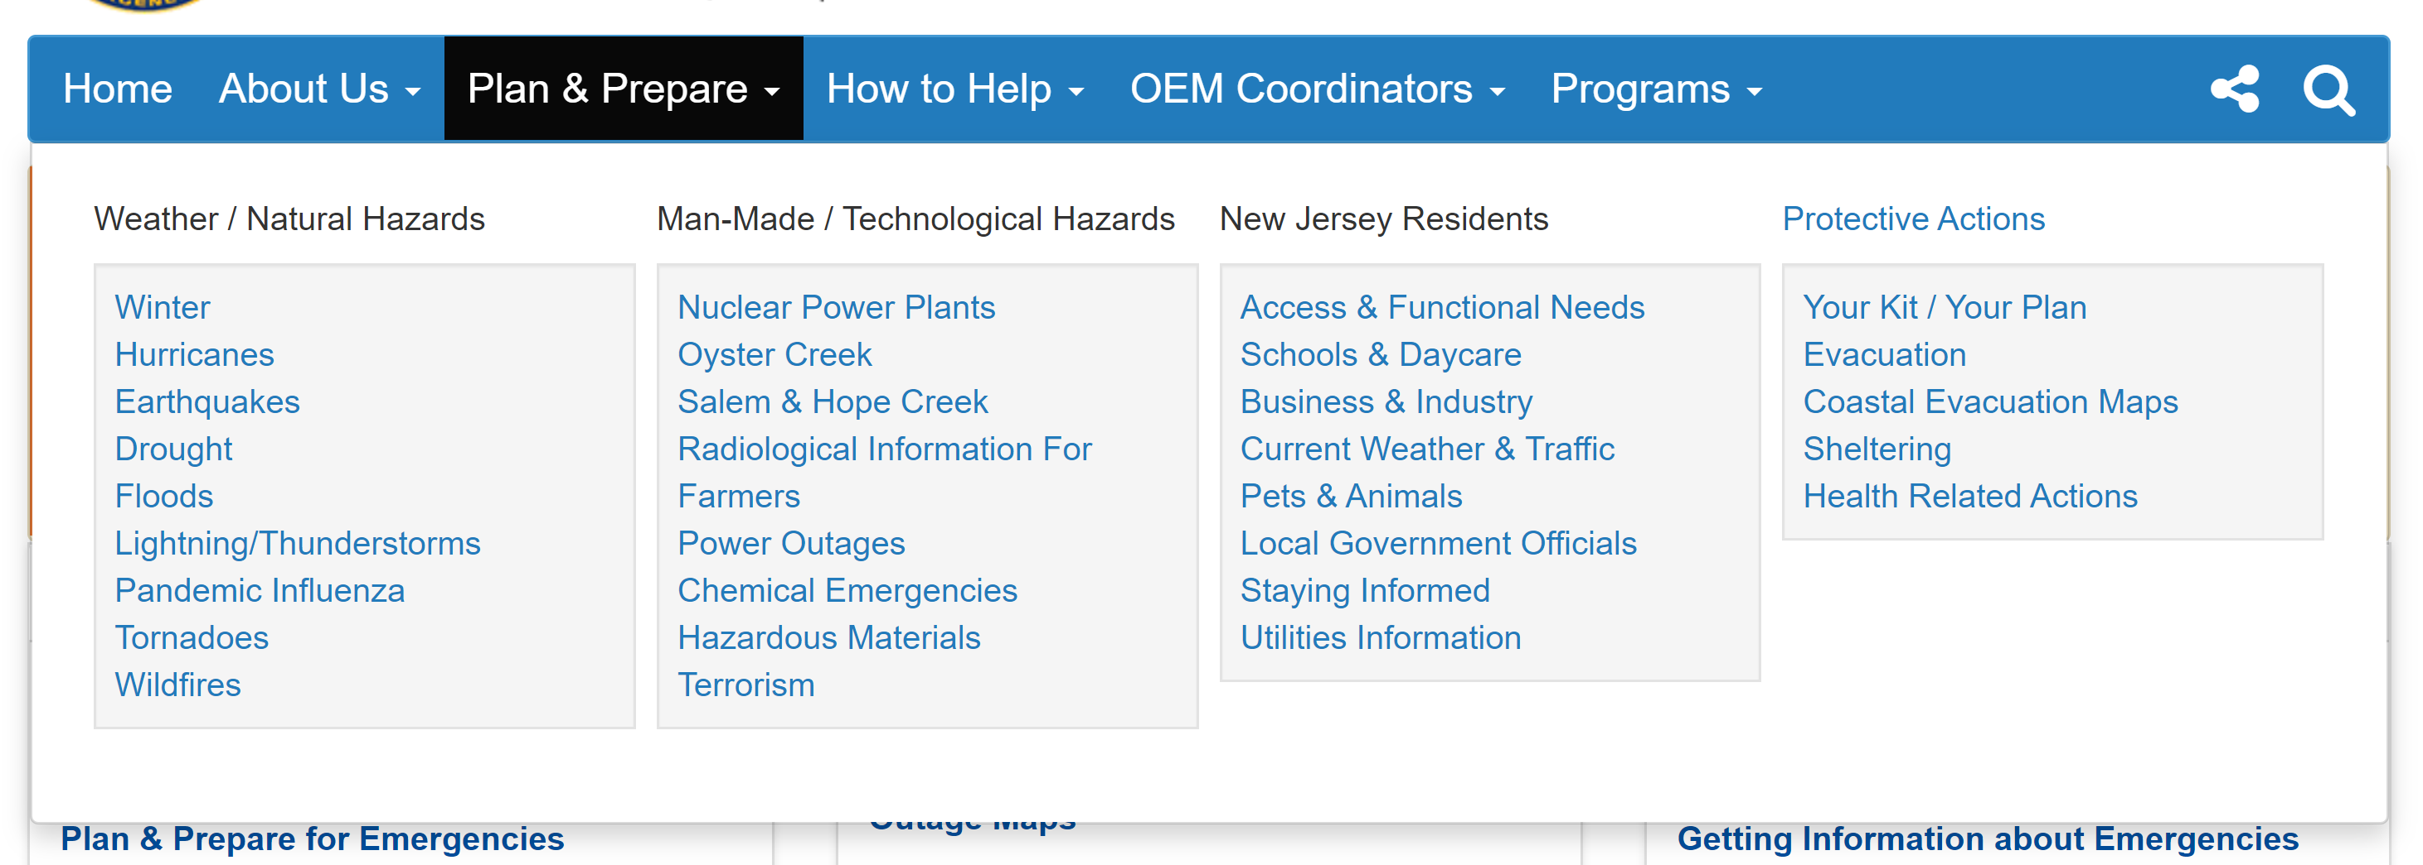

Figure 3: 